**• Define JSX**

**Ans.** JSX (JavaScript XML) is a syntax extension for JavaScript that looks similar to HTML. It is used in React to describe what the UI should look like. JSX allows you to write HTML-like code directly in JavaScript.

Example: **const element = <h1>Hello World</h1>;**

**• Explain about ECMA Script**

**Ans.** ECMAScript (often abbreviated as ES) is the standard specification on which JavaScript is based. It defines the core features and syntax of JavaScript. Different versions of ECMAScript are:

1. **ES5 (2009)**
2. **ES6 (2015)**
3. **ES7+**

**• Explain React.createElement()**

**Ans.** It is a React API method that creates a virtual DOM element.



**• Explain how to create React nodes with JSX**

**Ans.**  Each HTML-like tag inside JSX creates a React node.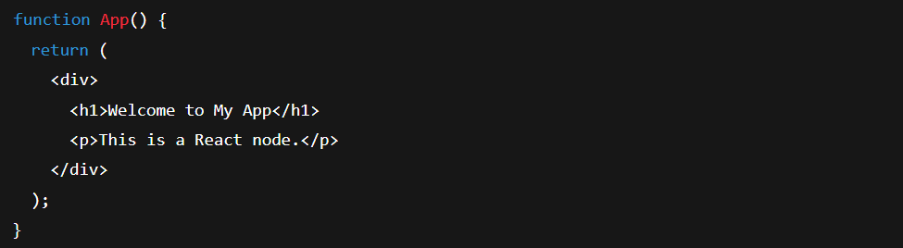

**• Define how to render JSX to DOM**

**Ans.** This renders the <App /> component into the HTML element with ID root.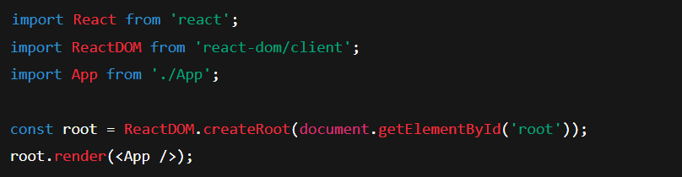

**• Explain how to use JavaScript expressions in JSX**

**Ans.** You can use JavaScript expressions in JSX using curly braces {}.

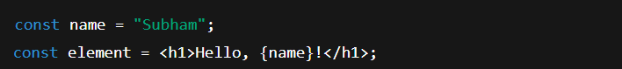

**• Explain how to use inline CSS in JSX**

**Ans.** To apply inline styles in JSX, use the style attribute with a JavaScript object.

